IAM Region Restriction – Implementation Report

Summary:

IAM users are restricted to operate only in us-east-1 (N. Virginia). A customer-managed policy deny-outside-us-east-1 enforces an explicit deny on all actions outside this region. Alongside, AmazonS3FullAccess provides S3 permissions, effectively limited to us-east-1 due to the deny condition. Testing confirmed compliance: requests in other regions fail, while requests in us-east-1 succeed.

Requirements:

- AWS Account with IAM access
- IAM User: vignesh-prod
- Custom IAM Policy: deny-outside-us-east-1
- Permission Policy: AmazonS3FullAccess

Flow Diagram:

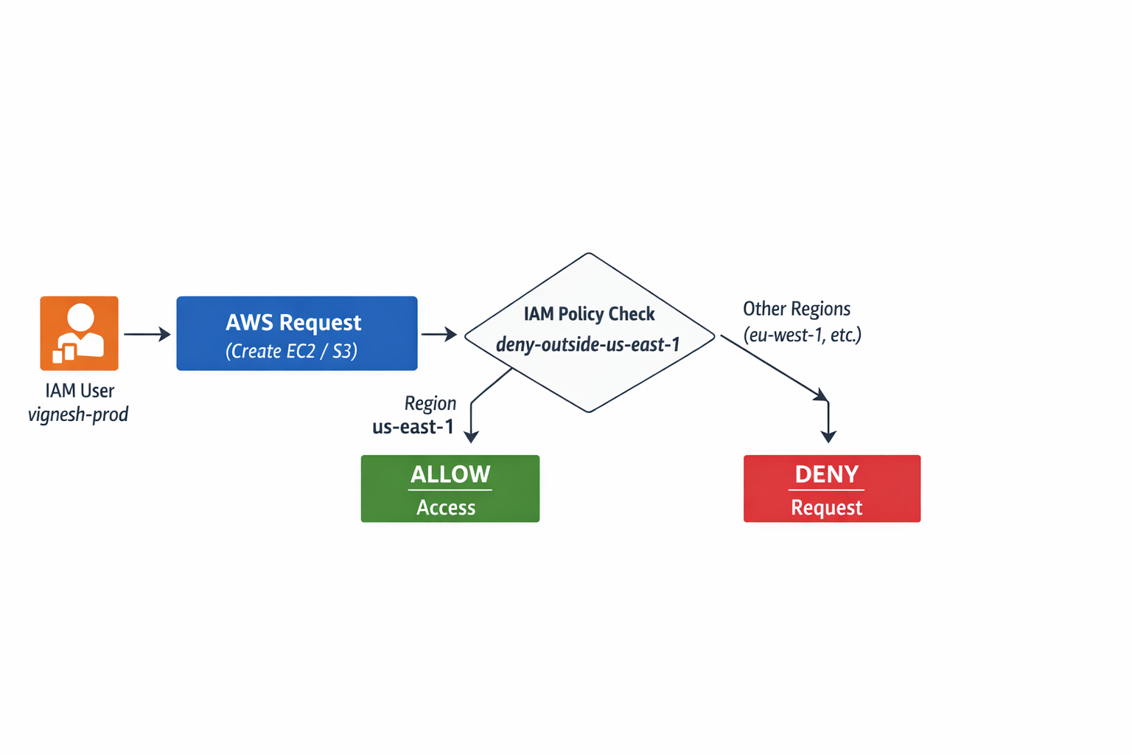

Results:

- EC2 launch in ap-south-1 → Denied
- EC2 launch in us-east-1 → Successful
- S3 bucket creation in us-east-1 → Successful
- S3 bucket creation in ap-south-1 → Denied

